GSM CONTROLLED SMART CAR

This paper advocates the operation of a concept car which is controlled by a mobile phone addressing the fact that the availability of mobile phones in today’s world is far greater then it was anytime earlier. There are different applications of this smart car given as follows:

1. GSM Controlled

The car is controlled by the mobile phone that makes a call to the mobile phone attached to the car. In the course of a call, if any button is pressed , a tone corresponding to the button pressed is heard at the other end of the call and by pressing the button on keypad makes the car to move in respective direction. This tone is called DTMF (dual-tone multiple- frequency). The car receives this DTMF tone with the help of the phone stacked in the car.

The received tone is processed with the help of DTMF

decoder MT8870. The decoder decodes the DTMF tone into its equivalent binary digit and this binary number is sent to the ULN 2003 Relay Driver.

In the project the car is controlled by a mobile phone that makes a call to the mobile phone attached to the car.

The received tone is processed by a circuit with the help of DTMF decoder mt8870. The mobile unit which is dedicated at the car is interfaced with an intellectual circuit so that it takes the responsibility of receiving commands in the form of call from the mobile unit and perform the corresponding predefined task such as move front or back or rotate. The circuit is also interfaced with few DC Geared motors in order to move the car in different directions. The ON and OFF of the dc motors depends upon the direction it has to move which is completely handled by IC uln2003 which is a relay driver IC and perform operation according to the output coming from mt8870.

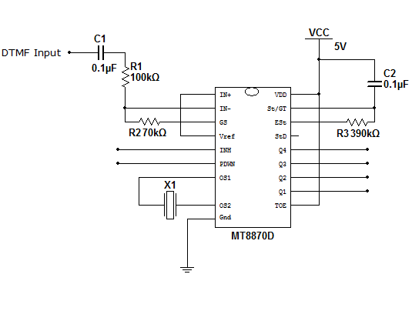

Circuit of the input and DTMF IC MT8870

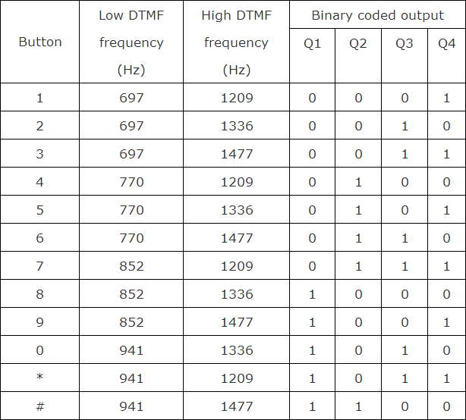

Table showing DTMF Low and High frequency tones and decoded outputs

1. Automatic Obstacle detection

Another great thing of this car is that It stops automatically when any object or other car on its way is about to hit. It prevents accident automatically. We use ultrasonic sensors for detection of obstacle in the way of the car. If the transmitted echo is received by the ultrasonic, the car automatically stops. If the ultrasonic receive the echo then it send the signal to Arduino uno which is attached to the ultrasonic and ULN 2003 relay driver IC. If the obstacle comes in front of the car, the ultrasonic sends signal to the Arduino and later Arduino send signal to ULN 2003 motor driver or relay driver IC to stops the motor which results in accident prevention.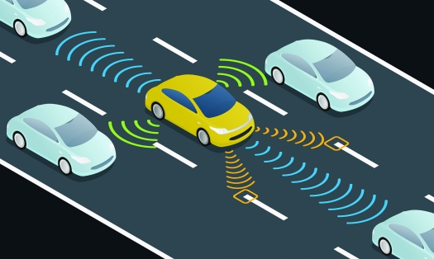

1. AHO(Automatically headline On)

As mentioned in its name, it is smart car then here is another thing which we added in this car which is automatically headlight on when there is darkness or night time.

LDR (Light dependent resistor) is attached to the headlight of the cars which result in clear view of the road in the night.

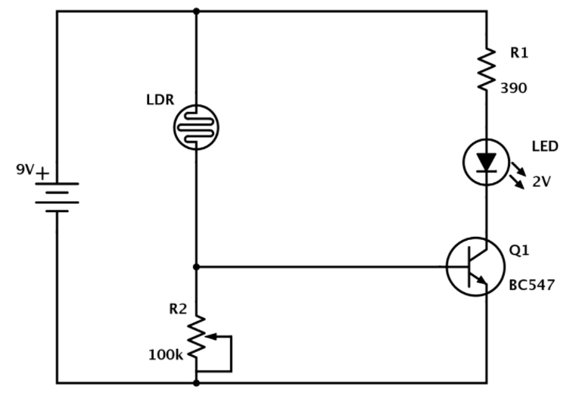

This circuit is used for the AHO

4.Mobile Camera is placed there for a great view:-

An old mobile phone is placed in front of the car and camera of the mobile is used for obtaining view of the front of the road.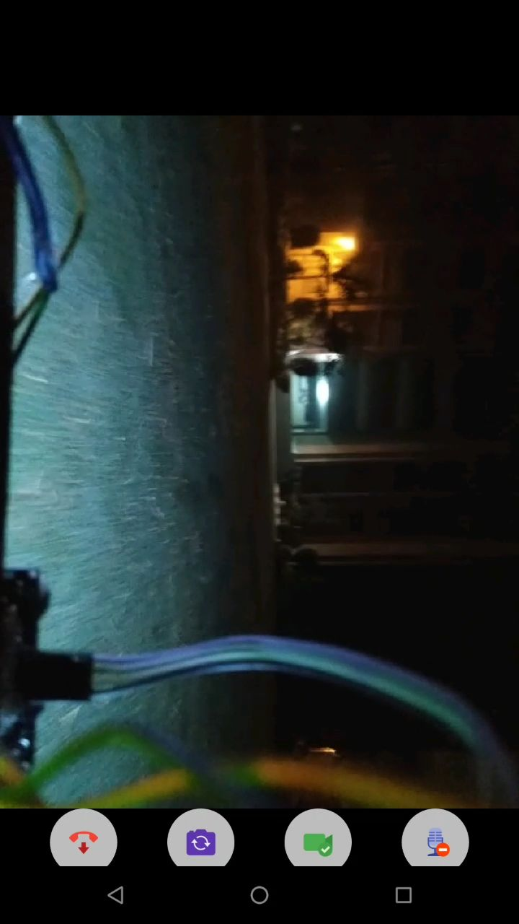

View of our college(MSIT) at night 2AM